Aquadeals s.r.o.
Zaječice 91
53835 Zaječice
Czech Republic
IČ: 03788547
DIČ: CZ 03788547
www.aquadeals.eu

Instructions for use
IGL - UV-C
T5 AM Series 90
T5 Amalgam Series 75/105 Watt T5 Short Series 63/44 Watt

High quality industrial UVC system for use in koi ponds, aquaculture,

Contents:
1) General safety instructions
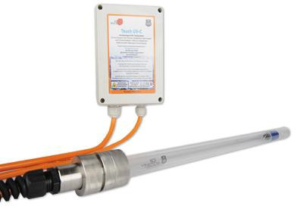
2) Technical data
3) Commissioning
4) Changing the lamp
5) Changing the quartz glass + seal
6) Placement of O-rings
7) Maintenance of the unit
8) Disposal
9) Contact details

1) General safety instructions

Dear Customer,
With the purchase of our product you will receive a high quality UV-C unit manufactured in the Czech Republic. UV component parts from German and Swiss manufacturers are used for the factory assembly. All components are certified with CE mark and come exclusively from primary production in the EU. This product includes components that can be changed or upgraded at any time to increase capacity as requirements increase. We attach great importance to the quality and functionality of our products. If, nevertheless, failures or defects should occur, please send us an email to: info@aquadeals.eu or contact your specialist dealer, who will forward your message to us. Your feedback is very important for us to be able to constantly improve our products.
Before operating the unit, read the operating instructions carefully and familiarise yourself with the unit. Keep the operating instructions; after 2 years, the lamps must be replaced. If you have mislaid them, you can download a PDF from our online shop: www.aquadeals.eu.

Please read carefully before use and commissioning:

Before using the UV-C lamp, first read the instructions for use carefully and please follow all instructions.
The unit contains glass components that can be damaged during assembly and disassembly. Therefore, first disconnect the unit from the mains before carrying out any work.
Caution: You will be working in a humid environment most of the time. To ensure your safety, protect yourself from electrical accidents. Never use a damaged unit and never connect it to the mains. If the quartz glass is damaged, the water will penetrate to the electrical installation. Immediately remove a damaged appliance from service (by disconnecting the plug from the mains).
Caution: The lamp produces strong UV-C radiation which can cause damage to eyes and skin within a very short time. UV-C safety goggles and other protective equipment are absolutely necessary. Do not expose persons, animals or plants to UV-C radiation. This would cause irreversible damage.
Therefore, the lamp may only ever be used in the housing or the slotted screen for UVC!!!
If you notice painful reactions, please contact a medical specialist. You must not stay in the areas where UV-C radiation occurs.

The UV-C radiation can also escape through the water from the filter chambers in which the UV lamps are located. For this reason, the unit must be disconnected from the mains before any work is carried out and before entering the UV-C application area.
The IGL UVC was built exclusively for partial disinfection for garden, swimming and koi pond systems and as such is only to be regarded as a partial component of an overall system. Manipulations, conversions, modifications or use outside the scope of application described above will invalidate any warranty.
The UV-C lamp may only be operated with a fully functional FI circuit breaker (30mA for humid environments). The unit must only be connected to sockets that are designed and approved for the correct IP protection class (in terms of the humid environment IP 44). It is also recommended to use a class D or 4 surge protector (depending on the relevant guidelines for a particular country) to protect the electronic components of the ballast from inductive mains overvoltages. Tampering of any kind with the electrical or electronic circuitry of the unit may result in a health hazard or malfunction of the unit. Installation may only be carried out by authorised electricians. Only persons who are appropriately qualified, have read these operating instructions and observe the operating instructions listed here may be entrusted with the commissioning, maintenance, operation and assembly.
It is necessary to check the tightness of the unit (by retightening the union nut on the head screw connection). The lamp must be installed in places with sufficient water flow to avoid overheating (and thus consequential damage to the unit). In winter, the lamp must be protected from freezing or dismantled. In case of freezing, the UV lamp and the quartz tube will most likely be damaged.
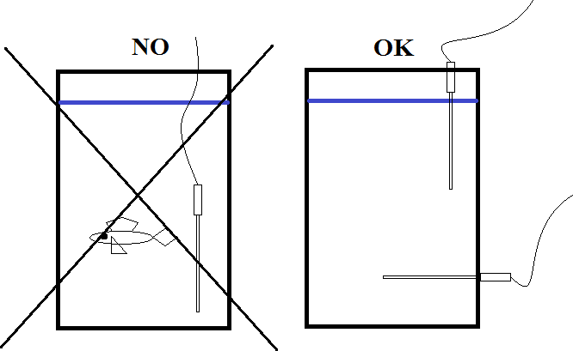

Manipulations, conversions, modifications or use outside the scope of application described above invalidate any warranty.
2) Technical data
Unit designation IGL UV-C AM Series IGL UV-C Amalgam Series
Lamp type T 5 Lamp T 5 Lamp
Power 90 Watt 105 Watt
Length of spotlight 875 mm 875 mm
Spotlight service life 2 years/16000 hours 2 years/16000 hours
Supply voltage 230V/50Hz 230V/50Hz
Max. Ambient temperature -20° to +50°C -20° to +50°C

Unit designation IGL UV-C Short Series IGL UV-C Short Series
Lamp type T 5 Lamp T 5 Lamp
Power 63 Watt 44 Watt
Length of spotlight 640 mm 440 mm
Spotlight service life 2 years/16000 hours 2 years/16000 hours
Supply voltage 230V/50Hz 230V/50Hz
Max. Ambient temperature -20° to +50°C -20° to +50°C

Unit designation IGL UV-C Short Amalgam Series
Lamp type T 5 lamp
Power 75 Watt
Length of spotlight 640 mm
Spotlight service life 2 years/16000 hours
Supply voltage 230V/50Hz
Max. Ambient temperature -20° to +50°C

3) Commissioning
Approved operators
The IGL UVC system may only be operated by persons who are at least eighteen years old and who have carefully read this operating manual.
The operator of the system is responsible to third parties in the operating area. He must prevent misuse and is therefore responsible for any damage caused by misuse.
Important notice:
The shipment of light fixtures and quartz glasses always poses a certain risk. A risk of breakage cannot be ruled out with any parcel service. For this reason, we have decided to pack the illuminant and the quartz tube separately.
Follow the installation instructions below and assemble the lamp. In doing so, you will get to know the device and also know how to replace the lamp after two years.
The industrial UVC is supplied in the following individual components:
The high-voltage unit is water-protected to IP 55 and packed in a plastic housing. It must not be placed in water and must be mounted suspended with the wall brackets (cable downwards). The supply lines to the plug and the lamp consist of a high-quality cable 5G 0.75. The line from the mains voltage part to the plug is approx.
The cable from the mains-voltage section to the lamp is approx. 3 m long. A longer cable between the ballast and the lamp should not be used to avoid any losses when starting the lamp.
The screw fitting of the lamp is made of high-quality chrome nickel steel AISI 316L, DIN 1.4404, X2CrNiMo 17-12-2 and is composed as follows:
At the end of the cable there is a screw connection in which the lamp socket is integrated. This is followed by the middle part of the gland with a double external thread and finally another gland.
Safety measures at the installation site
The container must be closed so that it is impervious to UV light when the UVC lamp is in operation. Always disconnect the UVC lamp from the mains before opening the container for maintenance or servicing. Never look into the light emitted by a switched-on IGL UVC. Always disconnect the IGL UVC from the mains before carrying out any installation or maintenance work. When laying the power cable (supply cable), care must be taken that it is not bent, cut, crushed or otherwise destroyed.
Stick the enclosed sticker (Caution UVC light) clearly visible on the container in which you place the UVC lamp.
Correct installation of the ballast
The ballast unit must be installed on a wall using the wall brackets. The power cables must point downwards. This ensures a tight seal of the box. If the box is simply laid down, condensation can cause leaks in the ballast unit and defects in the transformer. Faulty operation without suspension of the ballast unit and a resulting defect is not covered by the warranty.

Installation of quartz glass and UV lamp:
The lamp must always be installed in the housing or in the UVC chamber. It is best to place all parts horizontally on a table and proceed as follows during installation:
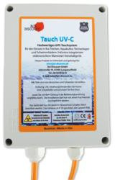

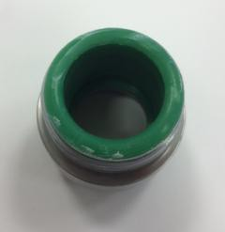
Push the quartz tube from the side where the rubber ring is located into the screw fitting as far as it will go. Note that there is a rubber ring (1) on the rear side - loose at the rear stop.
1
Visibility! It can fall out!

Secure the quartz glass with the enclosed union nut (2).
Tighten the nut only hand-tight. When delivered, all threads are lubricated. Make sure that no lubricant gets onto the rubber seals or the quartz glass.
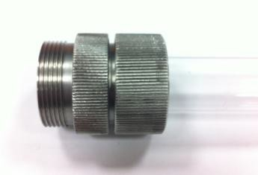

2

Now push the UVC lamp (4) into the quartz tube. Be careful to insert the lamp straight. With this length, little force is sufficient to break the quartz glass due to the resulting leverage effect. The lamp plug only fits in two positions.
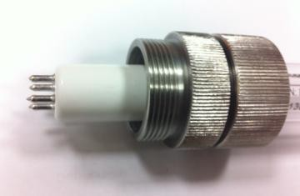

4

Loosen the black screw connection (9) on the plug. Now the white socket (5) is loose. Now you can determine the position of the UVC lamp in the quartz glass by pulling the orange cable. There should always be. 2-3mm space between lamp and quartz glass (10)

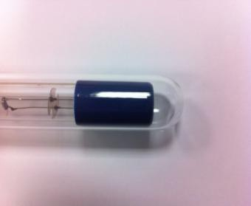
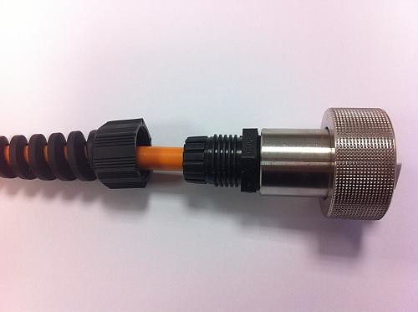

10

9

Connect the UVC lamp to the white socket (5). Please make sure that the thin O-ring inside is present (7).
Secure the lamp with the cap nut (6).
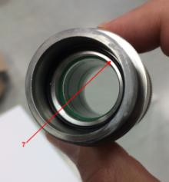
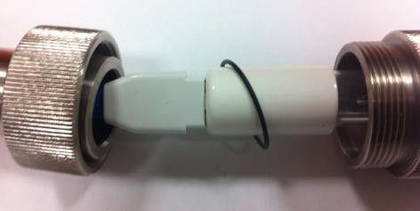

7
7
6
5

Now hand-tighten the second nut (6). Excessive force on the clamping screw (union nut) does not have much effect on the tightness of the housing and can cause mechanical damage to the quartz tube.
Check that there is 2- 3mm space between the lamp and the quartz tube (10). Then tighten the black screw connection (9) hand-tight again. The lamp must be seated almost as far as it will go on the end of the quartz glass, otherwise there may be leaks at the top of the cable! The insulation on the cable must not stick out of the black screw connection!
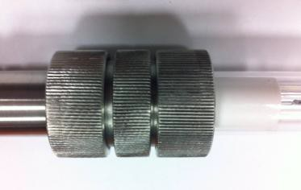

6

!Always proceed in this order, otherwise you may crack the quartz glass when turning the nut!
When changing the quartz tube, the seals must be lubricated before attaching the quartz tube to prevent damage to the glass. The end piece (head gland) is waterproof to IP 68, up to a pressure of 1 bar. The quartz tube is approved up to an external water pressure of 8 bar. However, it is recommended not to immerse the head gland completely and permanently in water.
If you choose to flange the lamp, the union nut of the quartz glass holder is replaced by a flange holder (8). Using the drilling template, drill the centre hole for the quartz glass and the four screw holes in the container. Now you can tighten the screws with the help of the counterpart. Make sure to put some polymer glue in the screw holes so that they are tight.
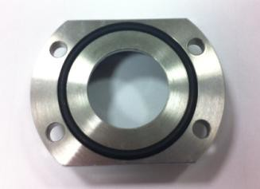
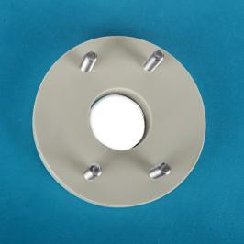
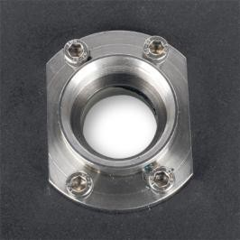
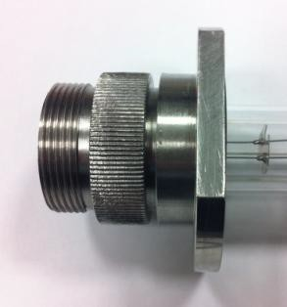

8

Commissioning with housing/ UVC chamber
This industrial UVC must always be installed in the housing or UVC chamber.
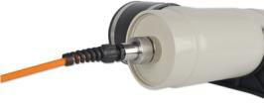
If you want to install the lamp in our housing, remove the union nut (2). Now you can screw the thread directly into the housing with the O-ring. Reach into the tubing with your hand so that you can aim the end of the quartz glass into the guide. It is best to loosen the black screw connection so that the lamp does not rotate with it. If the screw connection is tight, you can tighten the black screw connection again.

When installing the housing, make sure that the UV lamp is always in the water. The ideal installation is as follows. Fasten the lamp with the two enclosed pipe clamps. You do not need the fasteners. If you use the lamp as a pump version, please attach a reducing sleeve to the flexible sleeves and glue a hose nozzle into it.
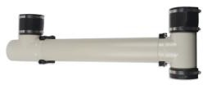

You can also install the housing as follows. Note, however, that the lamp becomes hot when water stops running through it. It is important that the water runs through the entire length and does not come out opposite.
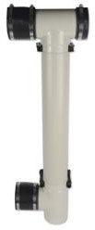
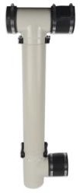

If you install the lamp in the UVC chamber, you can mount the thread directly in one of the holes provided.
!These installations always ensure that the UV radiation is not visible!

4) Lamp change
The industrial UVC is equipped with a T5 lamp which has a life span of 16000 hours or 2 years. If the lamp is not changed, the lamp will probably continue to shine with blue light, but the effect will no longer be present and a green water turbidity will occur.
The industrial UVC is designed so that the lamp can be replaced without removing the quartz glass or having to dismantle the UV unit from the system.
First loosen the black tension nut with strain relief located on the cable gland (9), then the union nut (6). If the nut cannot be loosened easily because it is dirty or too tight, use two pliers and protect the metal parts with a cloth. This way you can easily loosen the easily. Now you can disconnect the white plug from the lamp. Insert a new lamp. Whenever you change the lamp or the quartz glass, we recommend replacing the O-rings to ensure absolute tightness. The O-rings are available from us as replacements and you can order them right away with the new lamp. Tighten the nut (6) and the screw connection (9) again hand-tight. Make sure that the lamp reaches to within 2 - 3 mm of the end of the quartz glass, otherwise there may be leaks at the cable (seal).
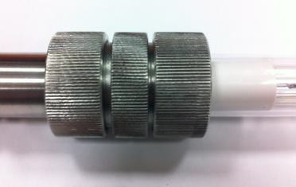

6

5) Change quartz glass and seals
The quartz glass is replaced in reverse order to the installation description. It only needs to be replaced if it is defective. For this purpose, loosen the union nut (2). If the nut cannot be loosened easily because it is dirty or too tight, use two pliers and protect the metal parts with a cloth. This way you can easily loosen the union nut. Now you can pull out the lamp with plug on one side and the quartz glass on the other side the quartz glass. Be careful when removing defective quartz glass, glass splinters can cause injuries. Insert a new quartz glass. Quartz glass replacement, the seals must be lubricated to avoid damage to the quartz glass. We recommend replacing the O-rings each time the lamp and quartz glass are changed to ensure absolute tightness. O-rings are available as replacements. As delivered, all threads are lubricated. Make sure that no lubricant gets on the rubber seals or the quartz glass.

2

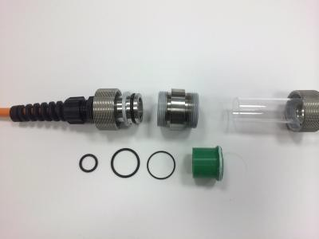
6) Replacement of O-rings
1
2
3
4
1: O-ring on cable connection
2: O-ring outside on plug connection
3: Thin O-ring inside on lamp side
4: Solid rubber on quartz glass side

7) Maintenance of the unit
Because of the adhering biofilm, you should clean the quartz glass with a damp cloth at regular intervals. This way you can ensure the performance of the UV lamp without removing the quartz glass.
8) Disposal
Please do not dispose of UVC lamps with household waste. UVC lamps belong in hazardous waste. Any recycling centre will take the lamps away free of charge.
9) Information
You can obtain all spare parts and matching accessories for our UV products at www.aquadeals.eu Our UVC can be retrofitted and converted at any time. Depending on the compatibility with the ballast, weaker or stronger lamps can also be used. The installation lengths or quartz glass lengths, including lamps, can also be varied.
At Aquadeals s.r.o., we consider competent advice on the optimal installation of UV-C systems to be a matter of course. If you have any questions about UV-C systems and their components, we are always at your disposal.
Please contact us, we will be happy to help you.
10) Contact details
Aquadeals s.r.o.
Zaječice 91
53835 Zaječice
Czech Republic
IČ: 03788547
DIČ: CZ 03788547
www.aquadeals.eu

